Implementing Web Application

**Create UI To Interact With Web Application**

|  |  |
| --- | --- |
| Team ID | PNT2022TMID43211 |
| Project Name | Nutrition Assistant Application |
| Date | 21 November 2022 |

# User interface that Interact with Web Application:

Login Page for Existing Users :

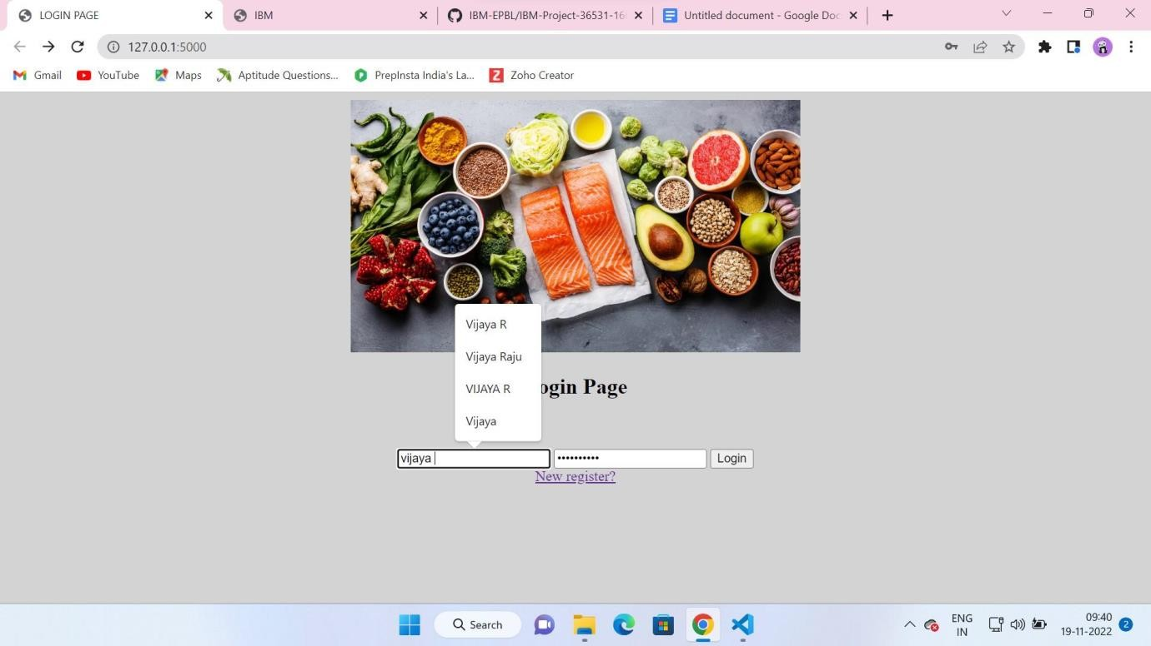

# Registration Page:

Registration Page for New Users :

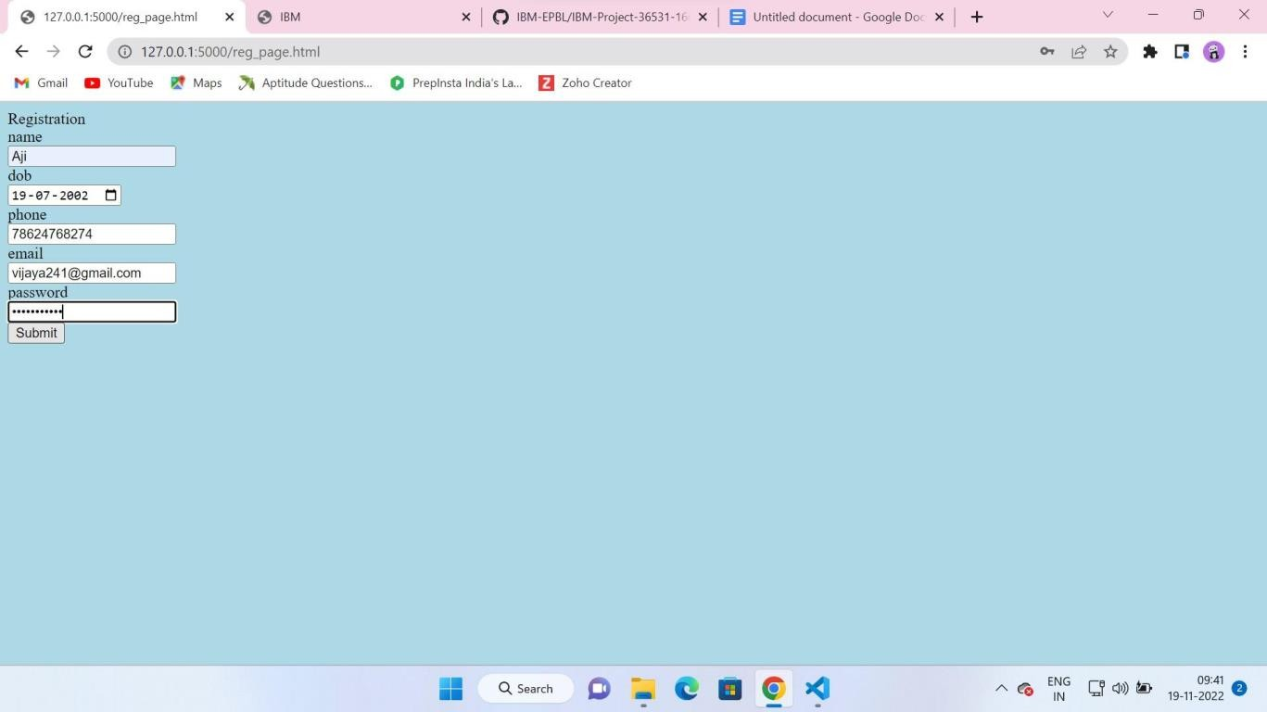

# User Interface:

User Interface Page to see about the BMI Calculations and Uploading Image :

